2026 Sponsor Packages
Grand Slam Sponsor - $5,000
•4’X10’ banner •Full Page Ad in Program • Business Announced During Games
•Commemorative Plaque • Business Advertised on Social Media
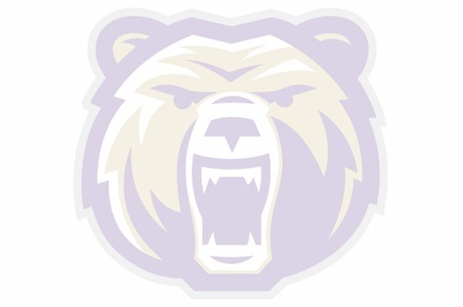
Home Run Sponsor - $1,000
• 2’x4’ banner •Full Page Ad in Program • Business Announced During Games
•Commemorative Plaque • Business Advertised on Social Media
Triples Sponsor - $750
• 2’x4’ banner •1/2 Page Ad in Program • Commemorative Plaque
• Business Advertised on Social Media
Doubles Sponsor - $500
• Name on large, shared banner •1/4 Page Ad in Program
• Business Advertised on Social Media
Singles Sponsor - $250
• Name on large shared banner •Company Logo on shared page in Program
• Business Advertised on Social Media
Other Sponsor - $Any Amount
- Name recognized on all social media

Business Name: _______________________________________________________________
Sponsor Contact: _______________________________________________________________
Address:______________________________________________________________________ Email: _______________________________ Phone: __________________________________
Donation Amount $___________ CK#: ___________ Cash:____________

***DEADLINE FOR SPONSORSHIP is Wednesday 12/15/2025***
Completed forms MUST be emailed to Jodi at jodi@jodilynnmartin.com prior to deadline
*Include your logo file to be used on the banner with the emailed form

Please make checks payable to “MHS Line Drive Club”

Don’t forget to follow your Lady Bears softball team on all social media platforms!
 Montgomery Lady Bear Softball 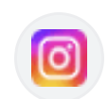 montgomery_softball 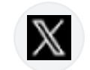 @MHSBearSB

